Enterprise Sales Application

Elbio Iseas, Minh Thien Tran, Neil Goldstein, Rob Fassett

DBM/460

October 24, 2016

Daniel McDonald

**Introduction**

The Enterprise Sales Application will help querying the data in the database in a fast and efficient way to allow analyze this information by giving decision makers the tools to make the write decisions for benefit of the company and to stay competitive in the market. This paper will discuss the advantages and disadvantages of an enterprise data warehouse, the ETL process, an ad-hoc reporting strategy, and a data mining strategy. Additionally, Lafleur Trading Company executive management team requested a business intelligence sales application to better monitor and analyze data in their application.

**Project Implementation**

**Discovery**

The discovery process is the gathering of requirements, and analyzing their definition. At this stage the project manager will collect information related to the technology, data, and applications required to accomplish the end result of a working data warehouse. Stakeholders will be identified, and interviewed and all basic elements of the initial design will be disseminated. (Poolet, 2009).

**Design**

The design process involves getting the basic models that will define the data warehouse together. This is a process that will be refined by key project participants being involved with the basic and final designs, Designs will apple to the technology, data, and application tracks defined in the discovery phase above.

**Develop**

Once the models of the data warehouse database and application are finalized, the actual data warehouse will go to the developers. The project manager will keep a close eye on the project as it develops to make sure that it fits the models set in the discovery and design phases, and meets the needs of the stakeholders.

**Deploy**

After the development phase wraps up, the database and supporting applications will be deployed to the users and stakeholders for initial testing and evaluation.

**Business Requirements**

As Lafleur Trading Company has grown and expanded over the years, servicing many locations all over the world, it has accumulated vast amounts of data. The current system being used to storage, monitor, and analyze the company’s data is no longer sufficient.

**Project MOV**

One of Lafleur’s organizational goals is to improve business decisions made by executives and managers, and improve sales. This project will support the organizational goal by improving data monitoring and analysis through the implementation of new data warehouse and business intelligence application. This project goal will be referred to as the *measurable organizational value* (MOV).

**Scope**

The following statements will help to define and limit the scope of the project so that unnecessary work is eliminated.

***Scope Statement***

* Create data warehouse for Enterprise Sales and Business Intelligence
* Develop data mining strategy for data warehouse
* Design executive dashboard for Business Intelligence metrics

***Out of Scope***

* Implement new Sales Application

**Stakeholders**

The Chief Operating Officer and VP of Operations for Lafleur are the sponsors of the project. The stakeholders include executives, managers, and users of the new data warehouse and business intelligence application.

**Dimensional Model**

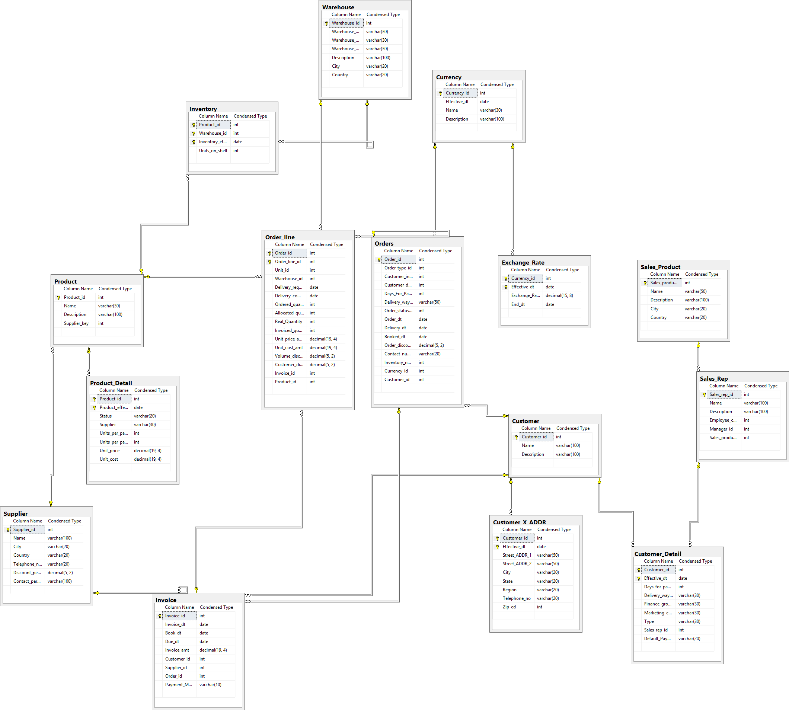

|  |
| --- |
| **Table** |
| Invoice |
| Shipment |
| Warehouse |
| Orders |
| Order_Line |
| Supplier |
| Product |
| Product_Detail |
| Customer |
| Customer_Detail |
| Customer_X_ADR |
| Currency |
| Exchange_Rate |
| Sales_Product |
| Sales_Rep |
| Inventory |

This enterprise sales application for Lafleur Trading Company will use a dimensional model with a Star schema with fact and dimension tables. It is integrated with sixteen tables listed below:

This dimensional model with a Star schema for the data warehouse has the advantages of the easiness for users to understand the data structure, navigation optimization, query performance, referential integrity, and load performance and administration. It also allows the use of special techniques statements to query the tables like STARjoin and STARindex.

**Advantages and Disadvantages of an Enterprise Data Warehouse**

An enterprise data warehouse is a centralized database comprised of data from many disparate sources. Disparate sources are sources that are different in kind and don’t allow for easy comparison. However, using tools to extract the data, transform it, and load it in to the data warehouse allows for a more in-depth look at all the data and allow critical business decisions to be made. This is one of the largest advantages of a data warehouse: the ability to see all the data from all the sources in one.

As the data is transformed for the data warehouse, the data is also cleansed. Meaning that all the data in the warehouse has been organized and all redundancies are eliminated. This is another advantage of a data warehouse: clean data. Additionally, with all the data being transformed, cleansed, and made available in one area, the data is centralized making it available for people in many different locations to analyze the data to make critical decisions.

The disadvantages of a data warehouse can be almost directly related to the advantages. While the data can be transformed and cleansed, this process can take years depending on the volume of data. Compatibility will also be a factor in the transformation process if the data sources are dated or there are too many constraints. Maintenance of the data warehouse will also be cumbersome with how much data is stored. Maintenance includes not only the data itself, but co-location costs, servers, and other technologies to support the data warehouse.

**ETL Process for Loading Data into the Database**

The process of Extraction Transformation and Loading (ETL) data for Lafleur Trading Company uses SQL Server Data Tools SSIS to import data from an Excel spreadsheet. In this file, there are the data for the sixteen tables of the database that the Enterprise Sales Application uses. The first step on the ETL is the “Data Extraction” (Ponniah, 2010) for identifying what are the data sources, platforms, and what files. The second step is “Data Transformation” (Ponniah, 2010) where data is checked for errors, customized, and getting ready for loading. The third step is “Data Loading” (Ponniah, 2010) which will insert that in the tables after deciding what will be the frequency of loading, and the time of the day. The following images show the Import and Export Wizard being used to load data into the data warehouse.

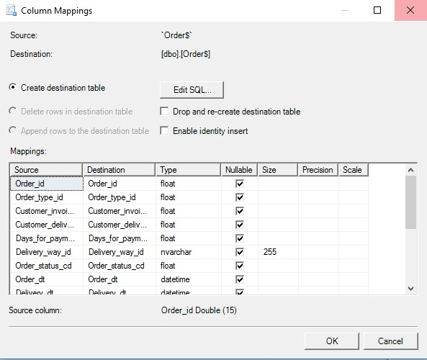

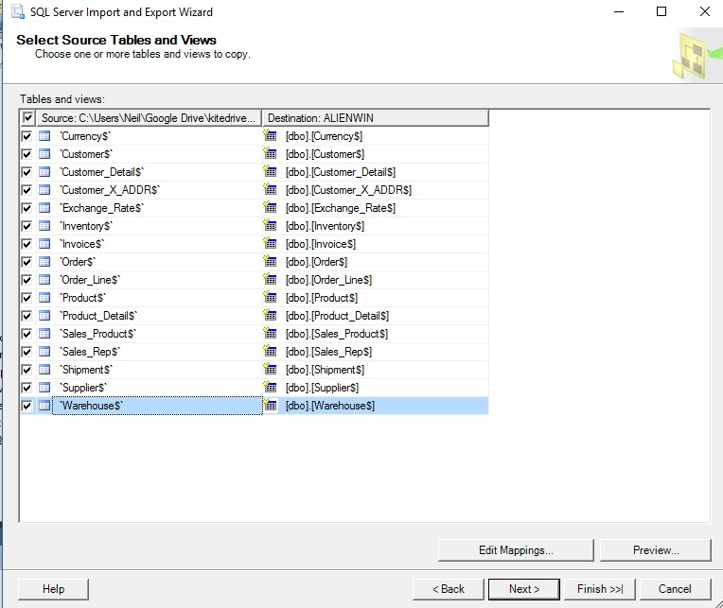

**Reporting Strategy Designs**

The client will need robust reporting applications to get useful information out of the data warehouse. Several reporting strategies will be proposed to cover this. Each of these strategies will be explained here. These strategies will include drill down analysis for moving from parent to child attributes, and drill across analysis for moving across dimensions in the data warehouse. A graphical dashboard will be designed for the users with easy to understand point and click, menus, and radio buttons for producing useful results.

**Ad-Hoc**

Ad-Hoc reporting is sometimes referred to being *on the fly*, or, something that does not already exist in the system and can be defined using OLAP dashboards (Rouse, 2010). Usually a point-and-click interface is presented to the user, allowing them to create the ad-hoc report. This is intended to be a one-time use report, but can frequently be saved to be reused as a report or a template for future reports. Sometimes an ad-hoc report can be used to drill deeper into a static report (explained below)

**Static**

Static reporting can be referred to as a *canned* report, or a report that is predefined without options, and does not update automatically as data changes. Static reports cannot be modified *on the fly* but just displayed.

**Parameter-Driven**

A parameter-driven report is a report where the user can customize results according to their needs by specifying parameters and specific operations (Computer Hope, 2016). Parameter driven reports are mostly defined and saved as a framework, and then run with specifics depending on the desired results.

**Data Mining Strategy**

Data mining will be used to help improve business management and operations in several ways. The first strategy is called affinity analysis (also called basket analysis), which helps to determine the correlation of activities between individuals or groups. In terms of Lafleur’s business, it will help determine purchase/order behaviors of customers. This will help the company develop strategies for upselling, cross-selling, loyalty programs, discounts, and product promotions. Data mining can also be used in sales forecasting to predict future sales. The company will be able to compute various cash flow projections and decide how much capital is needed to expand into other regions (Patel, n.d.).

Merchandise planning is another area where data mining will be used. Information gleaned from the data warehouse will help Lafleur determine what products customers want, how to price them, and what kind of merchandise competitors offer. Merchandise planning will also help the company keep a good balance of products in stock.

Market segmentation is an especially important strategy that utilizes data mining. Customers will be segmented into various segments such as buyer type, buyer location, product types, and other meaningful dimensions. Segmentation will help Lafleur understand its competition and customize its products and promotions to come out on top.

**Business Intelligence**

The general business intelligence (BI) framework of Lafleur Trading Company is comprised of data, people, processes, technology, and management (Coronel & Morris, 2015). The architectural components of the BI framework consist of the following:

1. ETL Tools
2. Data Store
3. Query and reporting
4. Data visualization
5. Data monitoring and alerting
6. Data analytics

SQL Server acts as the data store for Lafleur and, as discussed previously, SQL Server Integration Services (SSIS) will be used to perform ETL processes.

**Query and Reporting**

SQL Server Reporting Services (SSRS) will be used for query and reporting. For the purposes that Lafleur requires, there is no need to connect third party applications to the database, as SQL Server Reporting Services would be sufficient and easy to implement and maintain. SSRS is built with SQL queries in mind making it easier to build reports and with all the data being housed in SQL anyway, all the data is readily available.

Running a simple query will produce a lot of results in the reporting tool. Refer to Figure 1 for a query and results in SQL Server. The figure shows the query reaching out to the Product, Warehouse, and Order_Line tables to gather some information regarding what products were sold from which warehouse and for how much.

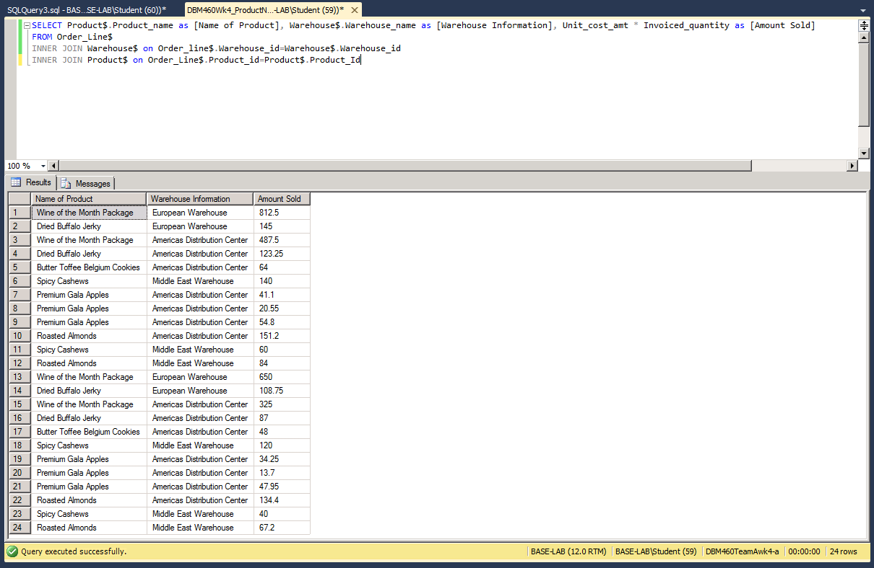

*Figure 1. Sample query.*

The SSRS application would be able to apply visuals to the reporting, as well as refresh the data on a reoccurring schedule so that sales associates would be able to see how much is being sold, which warehouses are being used, and the products that sell the most.

These queries could be run to create daily, monthly, yearly reports that delve a little deeper in the data and provide more granular results. Running this query on a dashboard would allow everyone to see live stats as they are sold. The dashboard could show any combination of tables and columns since it is all being run through the SQL Server line of tools.

**Data Visualization**

Data visualization is a crucial part of communicating information to the executive management team. The following encompass the majority of data visualization formats: dashboards, pie charts, graphs, and maps. Many data visualization tools are available and choosing the right one can be a challenge. Datazen was chosen for Lafleur’s business intelligence needs because it allows for a live connection to SQL Server for data monitoring/alerting; it contains a fully-featured dashboard publishing system; it can create rich, interactive visualizations. Furthermore, Datazen has native apps for every platform, which allows executive management to connect using any device.

The dashboard will consist of two main views: layout view and data view. Layout view displays visualization graphics such as graphs and gauges. A sample layout view is shown in Figure 2.

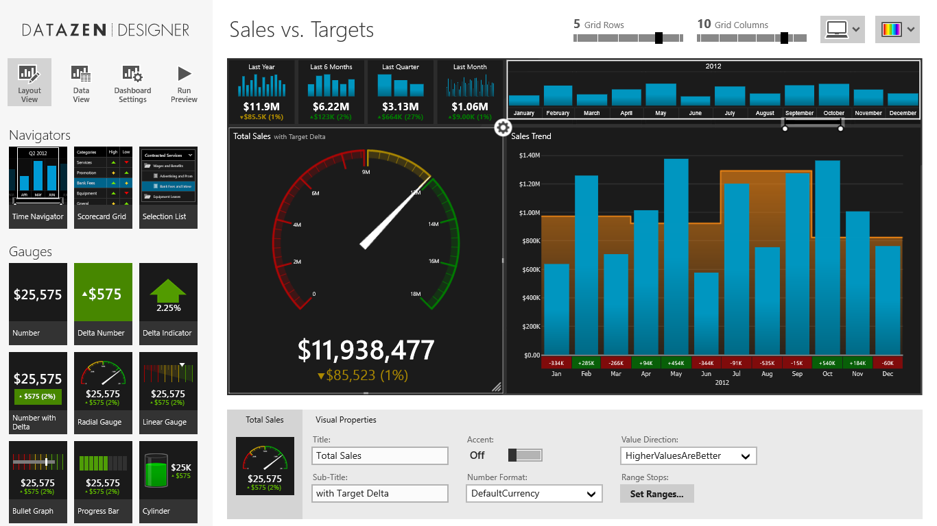

*Figure 2 (Dashboard in layout view, 2016).*

The data view is a supplement to the SSRS reports discussed above and displays any desired data in a table format. Figure 3 shows a sample of the data view.

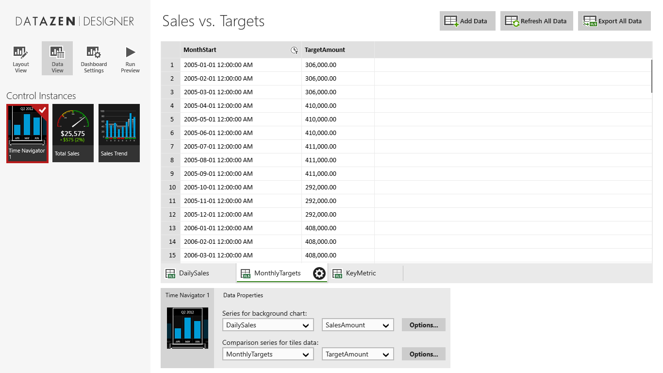

*Figure 3. (Data view, 2016)*.

**Conclusion**

Lafleur Trading Company, with the help of these SQL-based tools, should be able to increase sales, and efficiency by using business intelligence and being able to view and manipulate the results with a clean, easy to use dashboard. Hopefully, we will meet or exceed the industry average ROI for analytics of $10.66 per one dollar spent (Netke, 2012). We look forward to helping Lafleur implement these tools.

References

Ponniah, P (2010) Data Warehousing Fundamentals for IT Professionals, Second Edition. John Wiley & Sons, Inc.

Poolet, M. (2009). *Seven Steps for Successful Data Warehouse Projects*.*Sqlmag.com*. Retrieved 4 October 2016, from http://sqlmag.com/database-administration/seven-steps-successful-data-warehouse-projects

Coronel, C. & Morris, S. (2015). *Database systems: Design, implementation, and management* (11th ed.). Stamford, CT: Cengage Learning.

*Dashboard in layout view*. (2016). Retrieved from http://www.datazen.com/features/img/index/20131120/visuals/dashboard-in-layout-view.png

*Data view*. (2016). Retrieved from http://www.datazen.com/features/img/index/20131120/visuals/data-view.png

Linoff, G. S., & Berry, M. J. A. (2011). *Data Mining Techniques: For Marketing, Sales, and Customer Relationship Management (3rd ed.).* Indianapolis, IN: Wiley Publishing, Inc.

Netke, Shirish. (2012) *ROI on Analytics – Now We Have Numbers*. *Business Analytics 3.0*. Retrieved 18 October 2016, from https://practicalanalytics.co/2012/03/05/roi-on-analytics-now-we-have-numbers/

*Advantages and Disadvantages to Using a Data Warehouse | IT Training and Consulting – Exforsys*. (2016). *Exforsys.com*. Retrieved 5 October 2016, from http://www.exforsys.com/tutorials/data-warehousing/advantages-and-disadvantages-to-using-a-data-warehouse.html

Patel, N. (n.d.). *10 ways data mining can help you get a competitive edge*. Retrieved from https://blog.kissmetrics.com/data-mining/

Rouse, Margaret. (2016). *What is ad hoc analysis? - Definition from WhatIs.com*. (2016).*SearchBusinessAnalytics*. Retrieved 10 October 2016, from http://searchbusinessanalytics.techtarget.com/definition/ad-hoc-analysis

*What is Parameter-driven?*. (2016).*Computerhope.com*. Retrieved 10 October 2016, from http://www.computerhope.com/jargon/p/pa